General Register Implementation
(Final Report)

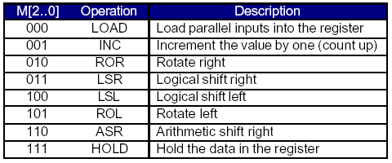

Ho, Hingkei SID: 103 079 575
Vega, Roberto Javier SID: 003 110 717
CS152A / EE116L
LAB 3, Sec 4 T.A. Wendong, Hu
Introduction:

This lab involved of building a general purpose register consistent of D-Flip Flops in the Altera software. The register should support preexisting functions, and additional functionality. The following table describes a list of the required operations:

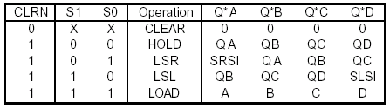

Design Description:

In order to implement the required functionality, the following table summarizes the connections and interoperations of the Digital Components and the D-Flip Flops used.

M[2..0] | Operation | Inputs Q[3..0] | S1 S0 | SRSI | SLSI
000 | LOAD | D3D2D1D0 | 1 1 | - | -
001 | INC | Z3Z2Z1Z0 | 1 1 | - | -
010 | ROR | Q0Q3Q2Q1 | 0 1 | Q0 / QD | -
011 | LSR | 0 Q3Q2Q1 | 0 1 | 0 | -
100 | LSL | Q2Q1Q0 0 | 1 0 | - | 0
101 | ROL | Q2Q1Q0Q3 | 1 0 | - | Q3 / QA
110 | ASR | Q3Q3Q2Q1 | 0 1 | Q3 / QA | -
111 | HOLD | Q3Q2Q1Q0 | 0 0 | - | -

M[3..0] : Input of the selected operation.
Q[3..0] : D-Flip-Flip output and data holded.
[ - ] : Don’t cares.
S[1..0] : Registers used to manage the basic operations.

From this table we were able to continue with the digital design of the M values and the Q values. There were required to create one extra table and from that table proceed to create the appropriate K-Maps.

The table and K-Maps are shown as follows:

Input and output states:

M[2..0] | Q[0..3]
000 | 0---
001 | 1---
010 | --00
011 | --10
100 | -0--
101 | -1--
110 | --01
111 | ----

K-Maps:

S1 = M1’
 | M0
1 | 1 | 0 | 0
 | 1 | 0 | 0 | M2
 |  | M1

S0 = M2’+M1M0’
 | M0
1 | 1 | 1 | 1
0 | 0 | 0 | 1 | M2
 |  | M1

Q0 = M0
 | M0
0 | 1 | - | -
- | - | - | - | M2
 |  | M1

Q1 = M0
 | M0
- | - | - | -
0 | 1 | - | - | M2
 |  | M1

Q2 = M0
 | M0
- | - | 1 | 0
- | - | - | 0 | M2
 |  | M1
Q3 = M2
 | M0
- | - | 0 | 0
- | - | - | 1 | M2
 |  | M1

With Q and S the values for the MUX can be determined for each operation by just doing the required combinational logic in the M[2..0] control bits. This idea is also applied to determine the control operation and the function desired in the general register. The attached forms show the diagram of the digital circuit designed and the output of the wave form that was created with the test cases. Also, the text of the TDF file that was used to try the logic is attached to this lab report.

